Martin Caesar Partogi
242310034
TI-24-PA2
Lab. PW
1.
<!DOCTYPE html>
<html>
<head>
<title>Latihan 1 - Typography</title>
</head>
<body>

<h1>Perkembangan Teknologi Web</h1>

<p>
Teknologi web berkembang sangat pesat seiring dengan kemajuan zaman.
Saat ini, website tidak hanya digunakan sebagai media informasi,
tetapi juga sebagai <b>platform bisnis</b> dan <i>komunikasi digital</i>.
</p>

<p>
HTML merupakan dasar dari pembuatan website. Dengan HTML, kita dapat
membuat struktur halaman seperti <strong>judul</strong>, paragraf,
gambar, dan elemen lainnya dengan mudah.
</p>

<p>
Selain HTML, terdapat juga CSS yang digunakan untuk mempercantik tampilan
website. CSS memungkinkan kita untuk mengatur warna, font, dan layout
sehingga tampilan menjadi lebih <em>menarik</em> dan <mark>responsif</mark>.
</p>

<p>
JavaScript juga berperan penting dalam pengembangan web modern. Dengan
JavaScript, website dapat menjadi lebih <u>interaktif</u> dan dinamis,
seperti validasi form, animasi, dan manipulasi data secara langsung.
</p>

</body>
</html>
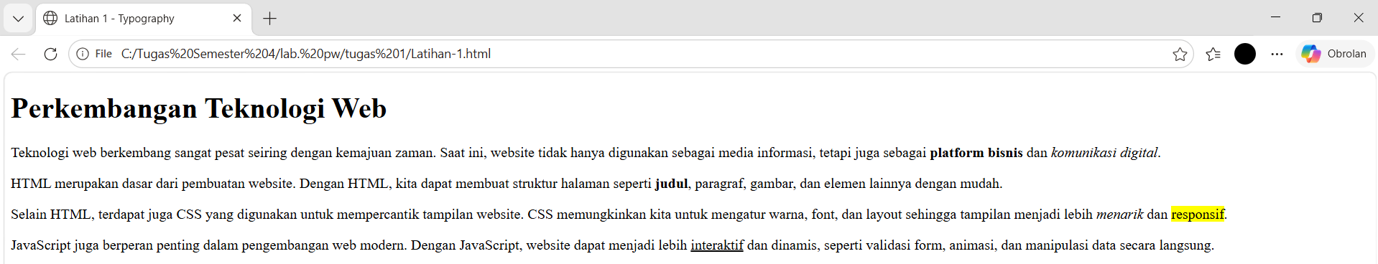

2.
<!DOCTYPE html>
<html>
<head>
<title>Latihan 2 - Image</title>
</head>
<body>

<h1>Perkembangan Teknologi Web</h1>

<p>
Teknologi web berkembang sangat pesat seiring dengan kemajuan zaman.
Saat ini, website tidak hanya digunakan sebagai media informasi,
tetapi juga sebagai <b>platform bisnis</b> dan <i>komunikasi digital</i>.
</p>

<img src="./images/teknologi web.jpg" alt="Gambar Teknologi Web">

<p>
HTML merupakan dasar dari pembuatan website. Dengan HTML, kita dapat
membuat struktur halaman seperti <strong>judul</strong>, paragraf,
gambar, dan elemen lainnya dengan mudah.
</p>

<img src="./images/codingan.jpg" alt="Gambar Coding">

<p>
Selain HTML, terdapat juga CSS yang digunakan untuk mempercantik tampilan
website. CSS memungkinkan kita untuk mengatur warna, font, dan layout
sehingga tampilan menjadi lebih <em>menarik</em> dan <mark>responsif</mark>.
</p>

<p>
JavaScript juga berperan penting dalam pengembangan web modern. Dengan
JavaScript, website dapat menjadi lebih <u>interaktif</u> dan dinamis.
</p>

</body>
</html>
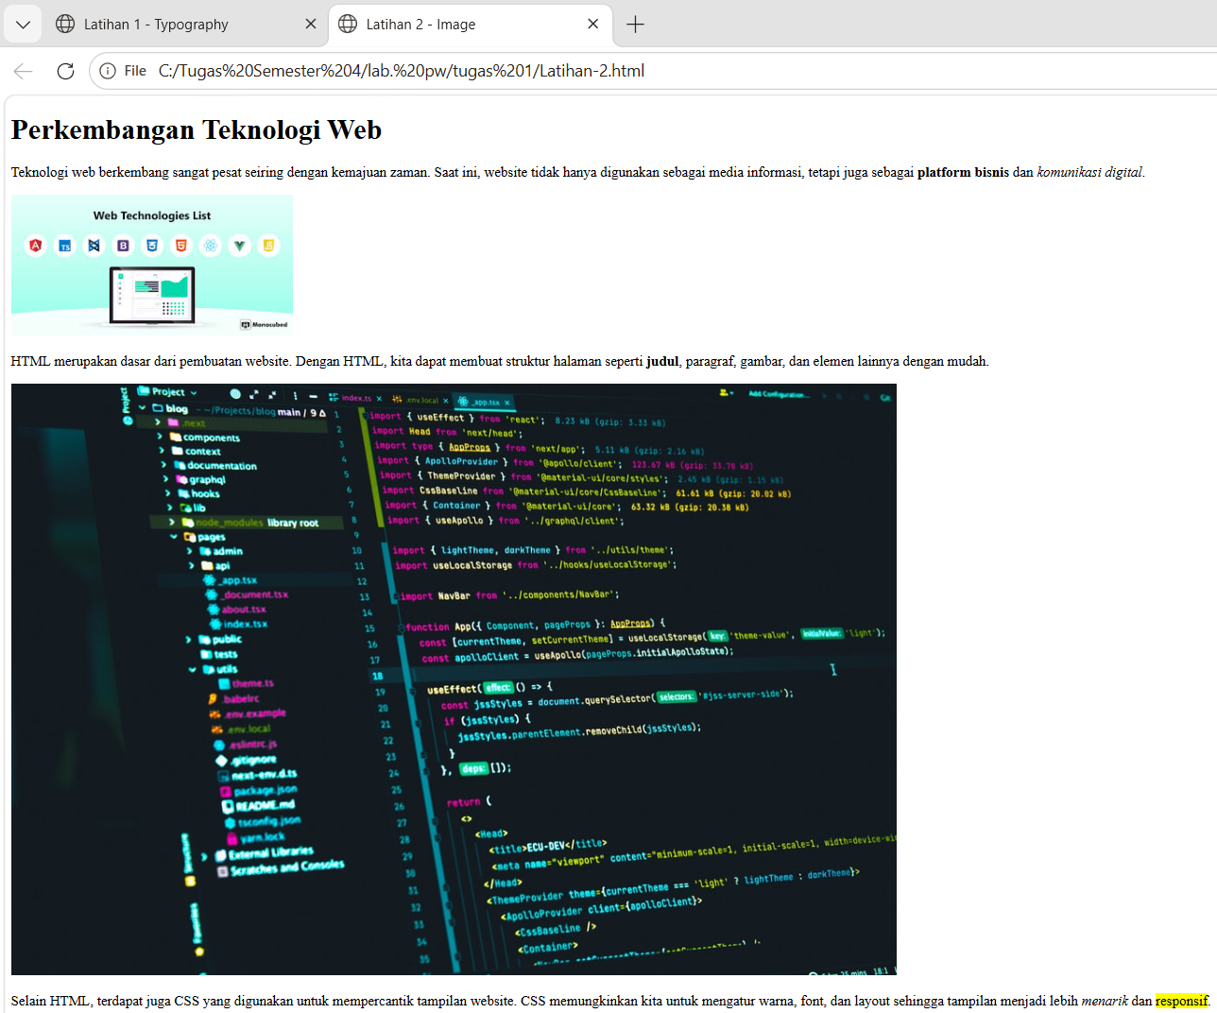

3.
<!DOCTYPE html>
<html>
<head>
</head>
<body>

<h1>Sifat Fisika Oksigen</h1>

<table border="1" cellpadding="5" cellspacing="0">
<tr>
<th>Parameter</th>
<th>Nilai</th>
</tr>
<tr>
<td>Massa atom relatif</td>
<td>15,994</td>
</tr>
<tr>
<td>Nomor Atom</td>
<td>8</td>
</tr>
<tr>
<td>Konfigurasi elektron</td>
<td>2s² 2p⁴</td>
</tr>
<tr>
<td>Jari-jari atom (nm)</td>
<td>0,074</td>
</tr>
<tr>
<td>Jari-jari X²⁻ (nm)</td>
<td>0,140</td>
</tr>
<tr>
<td>Keelektronegatifan</td>
<td>3,5</td>
</tr>
<tr>
<td>Energi ionisasi I (kJ/mol)</td>
<td>1316</td>
</tr>
<tr>
<td>Energi ionisasi II (kJ/mol)</td>
<td>3396</td>
</tr>
<tr>
<td>Kerapatan (g/cm³)</td>
<td>1.27 (padatan)</td>
</tr>
<tr>
<td>Titik leleh (°C)</td>
<td>-219</td>
</tr>
<tr>
<td>Titik didih (°C)</td>
<td>-183</td>
</tr>
<tr>
<td>Potensial elektroda (V)</td>
<td>+0.401</td>
</tr>
</table>

</body>
</html>
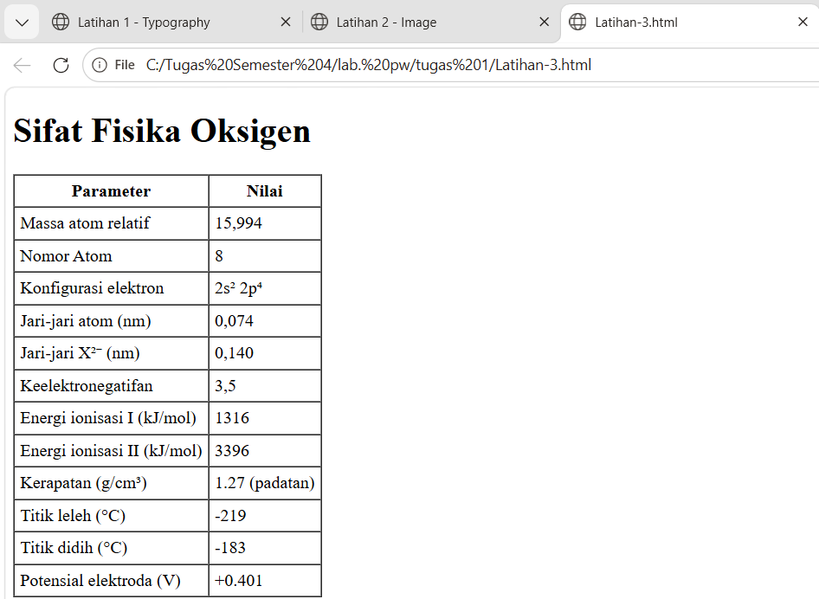

4.
<!-- Latihan 4 - Latihan List -->
<!DOCTYPE html>
<html lang="en">
<head>
<meta charset="UTF-8">
<meta name="viewport" content="width=device-width, initial-scale=1.0">
<title>Latihan List</title>
<style>
body {
justify-content: center;
margin: 50px;
}

.border-wrap {
border: 1px;
max-width: 600px;
flex: 1;
}
</style>
</head>
<body>
<div class="border-wrap">
<h1>The 10 Most Popular Programming Languages to Learn in 2022</h1>
<p>There’s no question that software programming is a hot career right now. The <span style="color: red">U.S. Bureau of Labor Statistics</span> projects 21 percent growth for programming jobs from 2018 to 2028, which is more than four times the average for all occupations. What’s more, the median annual pay for a software programmer is about $106,000, which is nearly three times the median pay for all U.S. workers.</p>
<p>Not all programming jobs are the same, however. Different roles, companies, and types of software require knowing and understanding different programming languages—and it’s often beneficial to know multiple languages. Trying to break into the field of software programming can be a daunting experience, especially for professionals with no prior programming experience.</p>
<p>The <u style="color: blue;">Master of Science in Computer Science Align program</u> at Northeastern University is specifically designed for students who want to transition into computer science from another field of study.</p>
<p style="text-align: center;"><q>Our aim is to transport students from a variety of different backgrounds and have them come out as software engineers,</q> says Ian Gorton, PhD and director of the graduate computer science programs at Northeastern University—Seattle. <q>We focus on math, programming, and a variety of computer science and engineering concepts.</q></p>
<p style="text-align: right;">Whether you’re new to programming or looking to brush up on your skills, it helps to know which languages are in high demand. Here are 10 of the most popular programming languages of 2020 based on the number of job postings listed on job search sites Indeed, the average annual salary for those jobs, and factors such as ease of use and potential for growth.</p>
<h1>Top 10 Most Popular Programming Languages</h1>
<ol>
<li>Phyton<br><span style="color: red;">Average annual salary:</span> <strong>$120.000</strong></li>
<li>JavaScript<br><span style="color: red;">Average annual salary:</span> <strong>$118.000</strong></li>
<li>Java<br><span style="color: red;">Average annual salary:</span> <strong>$104.000</strong></li>
<li>C#<br><span style="color: red;">Average annual salary:</span> <strong>$97.000</strong></li>
<li>C<br><span style="color: red;">Average annual salary:</span> <strong>$97.000</strong></li>
<li>C++<br><span style="color: red;">Average annual salary:</span> <strong>$97.000</strong></li>
<li>Go<br><span style="color: red;">Average annual salary:</span> <strong>$93.000</strong></li>
<li>R<br><span style="color: red;">Average annual salary:</span> <strong>$93.000</strong></li>
<li>Swift<br><span style="color: red;">Average annual salary:</span> <strong>$93.000</strong></li>
<li>PHP<br><span style="color: red;">Average annual salary:</span> <strong>$81.000</strong></li>
</ol>
<h1>7 Other Programming Language to Consider</h1>
<ul>
<li><strong>Web-based</strong> startups are more likely to be programming in <strong>Python</strong> and <strong>JavaScript</strong>.</li>
<li>Larger companies tend to develop their internal software applications using <strong>C#</strong> or Java and their <strong>Web applications using PHP</strong></li>
<li>Programs for data <em>analytics typically</em> use the <strong>R</strong> and <strong>MATLAB</strong> programming languages.</li>
<li><em><u>Embedded devices</u></em>, such as those in the automotive and healthcare industries, run software written in <strong>C, C++, or Rust</strong>.</li>
<li>Applications that run on the cloud are increasingly written in <strong>Go or Scala</strong>.</li>
<li><strong>Mobile applications</strong> are increasingly written in Swift or Kotlin.</li>
</ul>
</div>
</body>
</html>
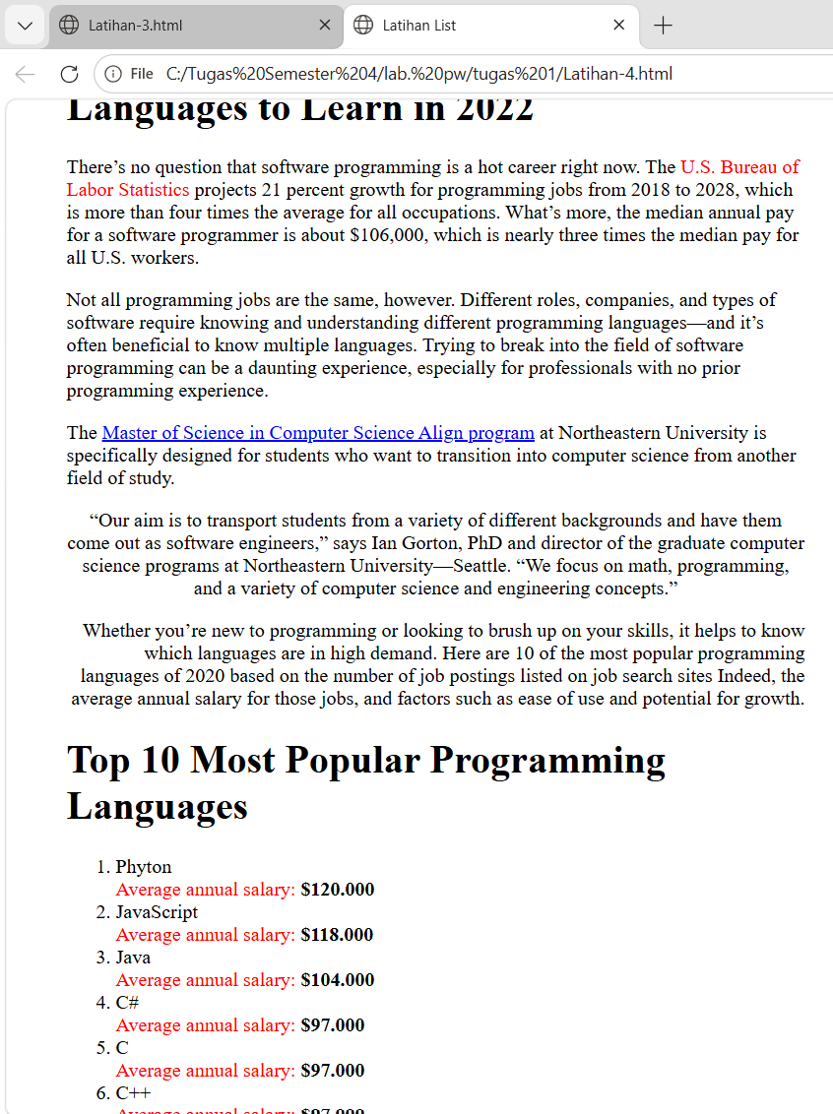
5.
<!-- Latihan 5 - Latihan Iframe, Block dan Inline -->
<!DOCTYPE html>
<html lang="id">
<head>
<meta charset="UTF-8">
<meta name="viewport" content="width=device-width, initial-scale=1.0">
<title>Latihan-5</title>
<style>
body {
font-family: Arial, sans-serif;
margin: 20px;
color: #000;
}

.container {
padding: 20px 40px;
max-width: 1000px;
}

h2 {
font-size: 22px;
margin-bottom: 20px;
}

.career-grid {
display: flex;
justify-content: space-between;
gap: 20px;
margin-bottom: 40px;
}

.career-column {
flex: 1;
display: flex;
flex-direction: column;
align-items: center;
}

.column-header {
border: 3px solid blue;
padding: 10px;
text-align: center;
font-weight: bold;
width: 80%;
margin-bottom: 20px;
min-height: 40px;
display: flex;
align-items: center;
justify-content: center;
}

.language-list {
list-style-type: none;
padding: 0;
margin: 0;
width: 100%;
max-width: 180px;
}

.language-list li {
display: flex;
align-items: center;
margin-bottom: 15px;
font-size: 18px;
font-weight: bold;
}

.language-list img {
width: 30px;
height: 30px;
margin-right: 15px;
object-fit: contain;
}

.iframe-container {
margin-bottom: 40px;
}

.latihan4-iframe {
width: 100%;
height: 240px;
border: 1px solid #000;
background-color: #e0e0e0;
}

.wiki-iframe {
width: 100%;
height: 400px;
border: 1px solid #000;
}
</style>
</head>
<body>
<div class="container">
<h2>Programming Language Base on Career</h2>
<div class="career-grid">
<div class="career-column">
<div class="column-header">Front-end Web<br>Development</div>
<ul class="language-list">
<li><img src="https://upload.wikimedia.org/wikipedia/commons/thumb/9/99/Unofficial_JavaScript_logo_2.svg/3840px-Unofficial_JavaScript_logo_2.svg.png" alt="JS"> JavaScript</li>
<li><img src="https://upload.wikimedia.org/wikipedia/commons/thumb/f/f3/Elm_logo.svg/960px-Elm_logo.svg.png" alt="Elm"> Elm</li>
<li><img src="https://upload.wikimedia.org/wikipedia/commons/thumb/f/f5/Typescript.svg/250px-Typescript.svg.png" alt="TS"> TypeScript</li>
</ul>
</div>
<div class="career-column">
<div class="column-header">Back-end Web<br>Development</div>
<ul class="language-list">
<li><img src="https://upload.wikimedia.org/wikipedia/commons/thumb/9/99/Unofficial_JavaScript_logo_2.svg/3840px-Unofficial_JavaScript_logo_2.svg.png" alt="JS"> JavaScript</li>
<li><img src="https://encrypted-tbn0.gstatic.com/images?q=tbn:ANd9GcTbfI5q7tOMvOuopXXzDQh9QupAknBug3-NIw&s" alt="Scala"> Scala</li>
<li><img src="https://upload.wikimedia.org/wikipedia/commons/thumb/0/05/Go_Logo_Blue.svg/1280px-Go_Logo_Blue.svg.png" alt="Go"> Go</li>
<li><img src="https://upload.wikimedia.org/wikipedia/commons/thumb/7/73/Ruby_logo.svg/250px-Ruby_logo.svg.png" alt="Ruby"> Ruby</li>
<li><img src="https://upload.wikimedia.org/wikipedia/commons/thumb/c/c3/Python-logo-notext.svg/1280px-Python-logo-notext.svg.png" alt="Python"> Python</li>
</ul>
</div>
<div class="career-column">
<div class="column-header">Mobile Development</div>
<ul class="language-list">
<li><img src="https://upload.wikimedia.org/wikipedia/commons/thumb/9/99/Unofficial_JavaScript_logo_2.svg/3840px-Unofficial_JavaScript_logo_2.svg.png" alt="JS"> JavaScript</li>
<li><img src="https://cdn-icons-png.flaticon.com/512/5968/5968282.png" alt="Java"> Java</li>
<li><img src="https://devprove.com/wp-content/uploads/2024/07/objectivec.jpg" alt="C"> Objective C</li>
<li><img src="https://encrypted-tbn0.gstatic.com/images?q=tbn:ANd9GcQ7ArFAzRlnvNsiH2OAPQaFb5g2ZyW73fRJoQ&s" alt="Swift"> Swift</li>
</ul>
</div>
</div>
<div class="iframe-container">
<h2>Top 10 Programming Language in 2022</h2>
<iframe src="Latihan-4.html" class="latihan4-iframe" title="Latihan 4">
<p>Browser Anda tidak mendukung iframe.</p>
</iframe>
</div>
<div class="iframe-container">
<h2>List of programming languages from Wikipedia</h2>
<iframe src="https://en.wikipedia.org/wiki/List_of_programming_languages" class="wiki-iframe" title="Wikipedia List">
<p>Browser Anda tidak mendukung iframe.</p>
</iframe>
</div>
</div>
</body>
</html>
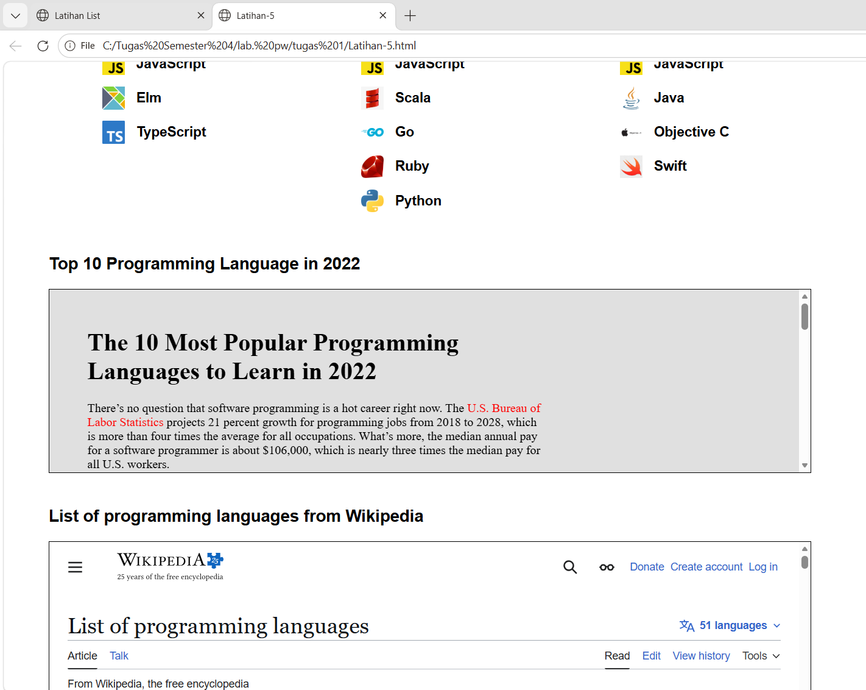

6.
<!-- Latihan 6 - Latihan Link -->
<!DOCTYPE html>
<html lang="en">
<head>
<meta charset="UTF-8">
<meta name="viewport" content="width=device-width, initial-scale=1.0">
<title>Latihan 6</title>
<style>
body {
margin: 40px;
}

.wrap-content {
max-width: 350px;
}
.content-media {
margin-bottom: 20px;
border: 1px solid;
max-width: 300px;
}
</style>
</head>
<body>
<div class="wrap-content">
<h1>Top 10 Daftar Bahasa Pemrograman</h1>
<h2>Daftar Isi:</h2>
<ul>
<li><a href="#content-phyton" target="_parent">Phyton</a></li>
<li><a href="#content-javascript" target="_blank">JavaScript</a></li>
<li><a href="/src/Latihan-4.html" target="_self">Java</a></li>
<li><a href="/src/Latihan-5.html" target="_blank">C#</a></li>
<li><a href="/src/Latihan-1.html" target="_top">C</a></li>
<li><a href="https://www.w3schools.com/cpp/default.asp" target="_blank">C++</a></li>
<li><a href="https://www.w3schools.com/go/index.php" target="_parent">Go</a></li>
<li><a href="https://www.w3schools.com/r/default.asp" target="_self">R</a></li>
<li><a href="https://www.w3schools.com/swift/default.asp" target="_blank">Swift</a></li>
<li><a href="https://www.w3schools.com/php/default.asp" target="_top">PHP</a></li>
</ul><br>
<div class="content-media" id="content-phyton">
<h1>Phyton</h1>
<p>Python adalah bahasa pemrograman tingkat tinggi yang populer, serbaguna, dan mudah dipelajari karena sintaksnya yang bersih serta mirip bahasa Inggris. Dikembangkan oleh </p>
</div>
<div class="content-media" id="content-javascript">
<h1>JavaScript</h1>
<p>JavaScript adalah bahasa pemrograman tingkat tinggi, dinamis, dan berbasis objek yang digunakan untuk membuat halaman web menjadi interaktif dan dinamis. Bersama HTML dan CSS, JavaScript adalah teknologi inti web yang berjalan langsung di browser (sisi klien) untuk menangani elemen seperti animasi, carousel gambar, dan menu dropdown.</p>
</div>
<p style="color: rgb(65, 63, 63);"><em>...dan seterusnya...</em></p>
</div>
</body>
</html>
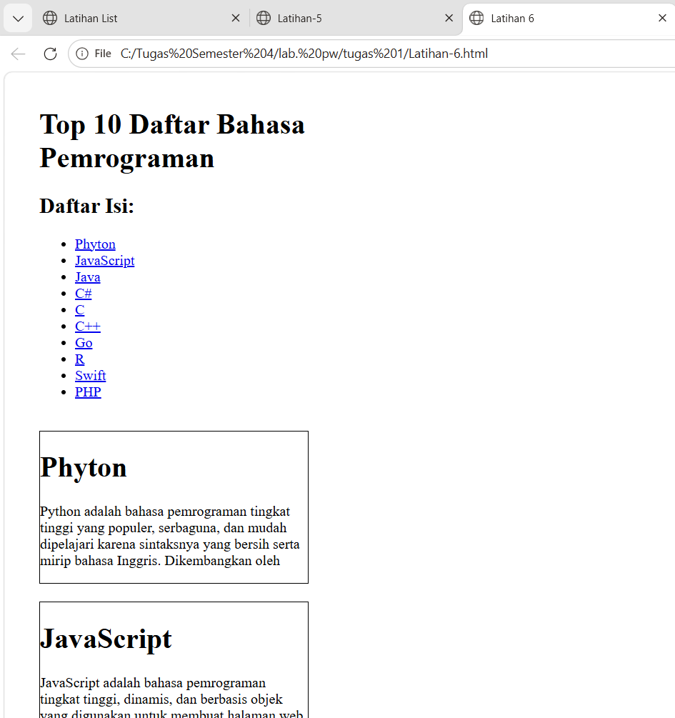

7.
<!-- Latihan 7 - Latihan Form -->
<!DOCTYPE html>
<html lang="en">
<head>
<meta charset="UTF-8">
<meta name="viewport" content="width=device-width, initial-scale=1.0">
<title>Latihan 7</title>
<style>
body {
margin: 30px;
}

.wrap-content-form {
display: flex;
flex-direction: column;
gap: 20px;
}

.wrap-content {
max-width: 400px;
}

.radio-btn {
display: flex;
flex-direction: row;
gap: 30px;
}

.radio-btn-gender {
display: flex;
flex-direction: row;
}

.btn-end {
display: flex;
flex-direction: row;
justify-content: space-around;
}

.lbl-in {
display: flex;
flex-direction: column;
}

.btn-sr {
min-width: 150px;
}
</style>
</head>
<body>
<div class="wrap-content">
<form action="" class="wrap-content-form">
<div class="lbl-in">
<label for="npm">Input your NPM</label>
<input type="text" name="npm" id="npm">
</div>
<div class="lbl-in">
<label for="fname">Input your Fullname</label>
<input type="text" name="fname" id="fname">
</div>
<div class="lbl-in">
<label for="email">Input your Email</label>
<input type="email" name="email" id="email">
</div>
<div class="lbl-in">
<label for="password">Input your Password</label>
<input type="password" name="password" id="password">
</div>
<div class="lbl-in">
<label for="placebirth">Input your Place Birth</label>
<input type="text" name="placebirth" id="placebirth">
</div>
<div class="lbl-in">
<label for="birthdate">Input your Birthdate</label>
<input type="date" name="birthdate" id="birthdate">
</div>
<div>
<label for="">Input your Gender</label>
<div class="radio-btn">
<div class="radio-btn-gender">
<input type="radio" id="male" name="gender" value="male">
<label for="male">Male</label>
</div>
<div class="radio-btn-gender">
<input type="radio" id="female" name="gender" value="female">
<label for="female">Female</label>
</div>
</div>
</div>
<div class="lbl-in">
<label for="address">Address</label>
<textarea name="address" id="address" rows="10" cols="30" placeholder="Input your Address"></textarea>
</div>
<div class="btn-end">
<button type="submit" class="btn-sr">Save</button>
<button type="reset" class="btn-sr">Clear</button>
</div>
</form>
</div>
</body>
</html>
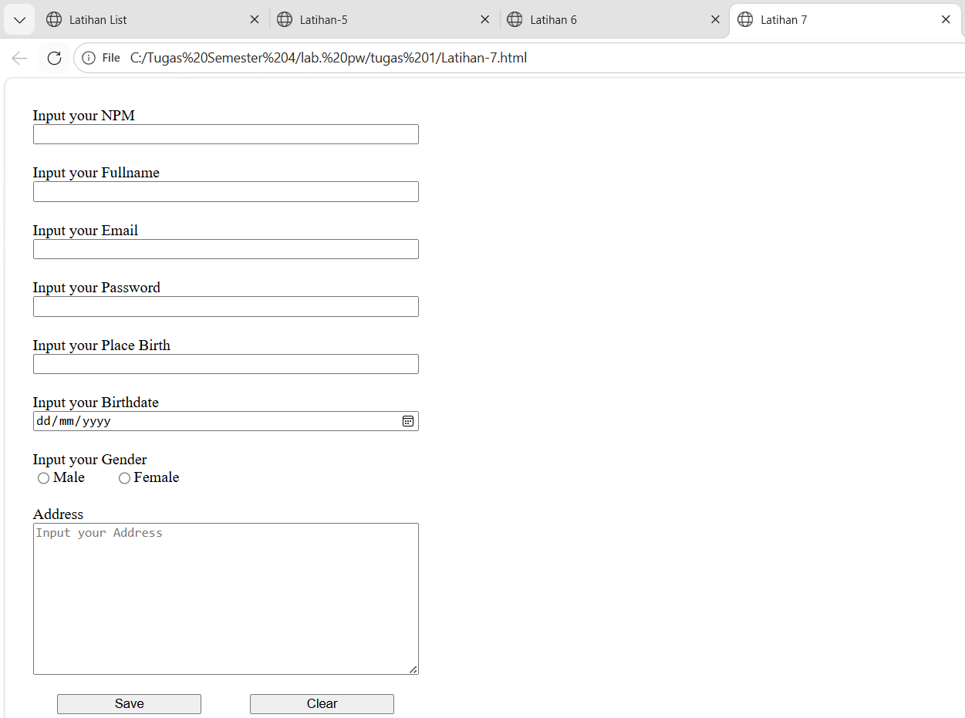

8.
<!DOCTYPE html>
<html lang="id">
<head>
<meta charset="UTF-8">
<meta name="viewport" content="width=device-width, initial-scale=1.0">
<title>Portofolio Pribadi</title>
<style>
body {
font-family: Arial, sans-serif;
background: linear-gradient(135deg, #eef2f3, #dfe9f3);
color: #333;
margin: 0;
padding: 20px;
display: flex;
justify-content: center;
}

.container {
background: #fff;
max-width: 850px;
width: 100%;
border-radius: 12px;
box-shadow: 0 5px 15px rgba(0, 0, 0, 0.1);
overflow: hidden;
}

.hero {
background: #34495e;
color: white;
text-align: center;
padding: 35px 20px;
}

.hero h1 {
margin: 0;
font-size: 30px;
}

.hero p {
margin-top: 8px;
font-size: 18px;
}

main {
padding: 30px;
}

section {
margin-bottom: 25px;
}

h2 {
color: #34495e;
border-left: 5px solid #3498db;
padding-left: 10px;
}

ul {
padding-left: 20px;
}

table {
width: 100%;
border-collapse: collapse;
margin-top: 10px;
}

th, td {
border: 1px solid #ccc;
padding: 10px;
}

th {
background-color: #3498db;
color: white;
}

.btn {
display: inline-block;
padding: 10px 18px;
margin-right: 10px;
background-color: #2ecc71;
color: white;
text-decoration: none;
border-radius: 6px;
}

.btn:hover {
background-color: #27ae60;
}

footer {
background: #f1f1f1;
text-align: center;
padding: 15px;
font-size: 14px;
}
</style>
</head>
<body>

<div class="container">
<div class="hero">
<h1>Martin Caesar Partogi</h1>
<p>NPM 242310034 | Mahasiswa Teknologi Informasi</p>
</div>

<main>
<section>
<h2>Profil Singkat</h2>
<p>
Saya adalah mahasiswa Teknologi Informasi yang memiliki minat pada
pengembangan web, jaringan komputer, dan teknologi digital.
Saya senang belajar hal baru untuk mengembangkan keterampilan di bidang IT.
</p>
</section>

<section>
<h2>Keahlian</h2>
<ul>
<li>HTML dan CSS Dasar</li>
<li>Jaringan Komputer</li>
<li>Microsoft Office</li>
<li>Desain sederhana</li>
</ul>
</section>

<section>
<h2>Pendidikan</h2>
<table>
<tr>
<th>Tahun</th>
<th>Sekolah / Kampus</th>
<th>Jurusan</th>
</tr>
<tr>
<td>2024 - Sekarang</td>
<td>Institut Bisnis dan Informatika Kesatuan</td>
<td>S1 Teknologi Informasi</td>
</tr>
<tr>
<td>2021 - 2024</td>
<td>SMK Grafika Mardi Yuana</td>
<td>Teknik Produksi Grafika</td>
</tr>
</table>
</section>

<section>
<h2>Kontak</h2>
<p>Hubungi saya melalui email atau GitHub:</p>
<a href="#" class="btn">Email</a>
<a href="#" class="btn">GitHub</a>
</section>
</main>

<footer>
<p>&copy; 2026 Martin Caesar Partogi | 242310034</p>
</footer>
</div>

</body>
</html>

